

**Guide to Completing**

**Maine JobLink (MJL)**

**Registration for Apprentices**



As a registered apprentice (RA) with the Maine Apprenticeship Program, all apprentices are required to create an account with the Maine JobLink (MJL) for case management and funding purposes.

MJL is a free and easy cloud-based job board that features improved job search and job matching functions, notifications of job match by email, a professional resume builder, support for more than 60 languages using Google Translate and a mobile-friendly design for smartphones and tablets.

The MJL website strives to comply with the best practices and standards as defined by Section 508 of the U.S. Rehabilitation Act and Level AA of the World Wide Web Consortium (WC3) Web Content Accessibility Guidelines 2.0. These guidelines outline how to make web content more accessible for people with disabilities.



*The Maine Department of Labor provides equal opportunity in employment and programs. Auxiliary aids and services are available to individuals with disabilities upon request. This program is provided in partnership with the American Job Center network.*

**To access the Maine JobLink website, visit the Maine CareerCenter page:** [www.mainecareercenter.gov](http://www.mainecareercenter.gov)

**Step 1: Creating Your Job Seeker Account**

1. At the **Maine CareerCenter** webpage, click on the **Maine JobLink** tab
2. On the Maine JobLink home screen, click on **LOG/IN REGISTER**
3. In the pop-up box select **Job Seeker**
4. On the next screen, click on the blue box, **Create a Job Seeker Account**
5. You should be at the **Create Job Seeker Account** screen.

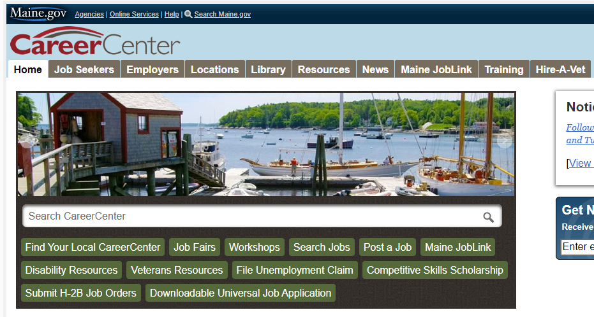

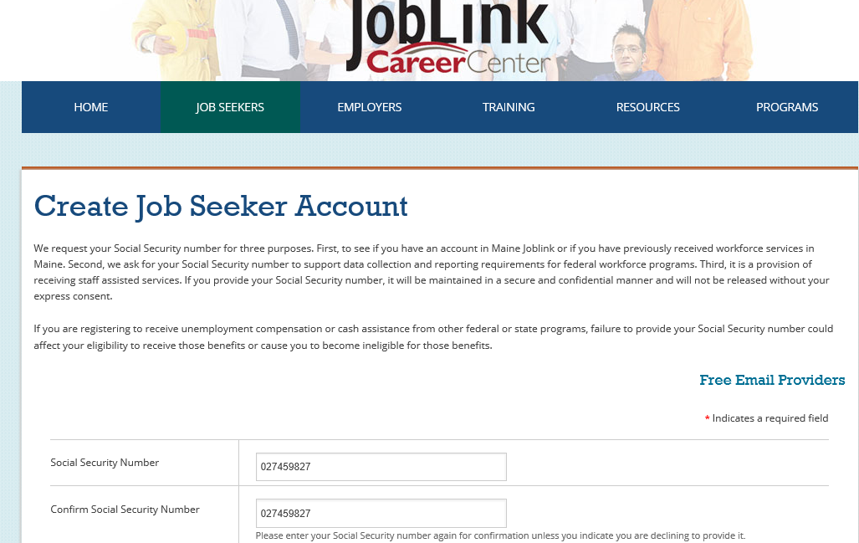

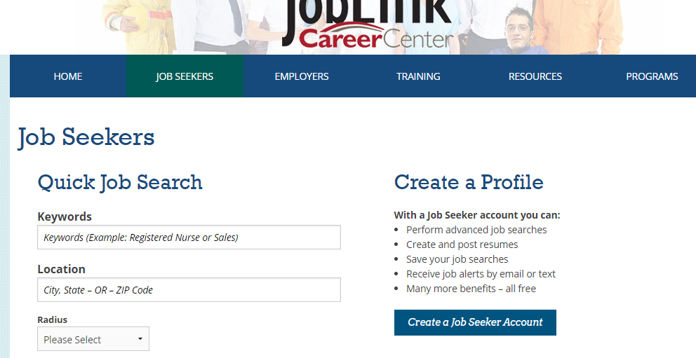

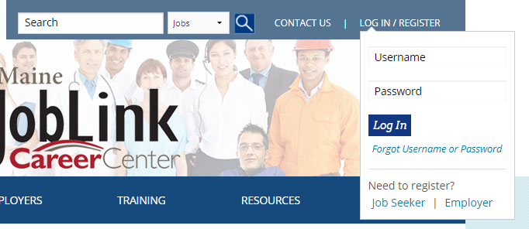



At the **Create Job Seeker Account** screenthere are several sections**.** Click in the box with your cursor tocomplete the sections**.** The red asterisk indicates a required field.

**Special Note: As an apprentice you are not required to supply your social security number. However, in order to receive federal dollars and keep this service free, we are required to ask for your social security number**. If you decide to enter your social security number, it is not made available to employers or the public. To avoid identity theft, state-of-the-art software has been installed to prevent hacking into the system. If you decide to enter your Social Security Number, do NOT select the “*I decline the entry of my Social Security number”* option. You will be asked to confirm your Social Security Number. (*When you provide your Social Security number, only the last 4 digits will be shown and it will be maintained in a secure and confidential manner and will not be released without your express consent.)*

* + - * Account Information section
* Create a **username**: 6 to 20 characters – no spaces
* Confirm Username
* Create a **password**: Must be between 8 – 20 characters. Must include letters, at least 1 number and at least 1 special character ~ (Special character example: * $ # ! % + )
* Confirm Password
* Select a **Security Question**
* Provide answer to Security question in the Security Question Answer box

Note: for future reference, when asked you will need to type your security question exactly as your original answer.

**NOTE**: **Please save and remember your Username and Password – You will need it again prior to completing your registration**



* + - * Profile InformationSection
* Complete the Profile Information and click on ***Continu*e** in the blue box.

At the **Terms of Agreement** screen,

1. Read all 3 authorization sections listed below:
   * + - *Information Privacy*
       - *Equal Opportunity Statement*
       - *Customer Right to File a Complaint*)
2. At the bottom of your screen you will see two 🗹 check boxes. To accept all 3 sections, click in the check box stating “I agree to share my information ….

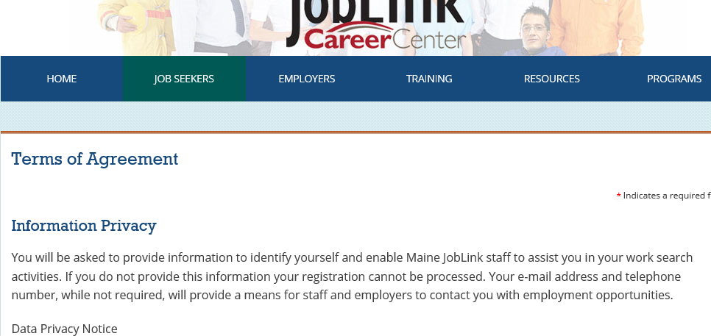

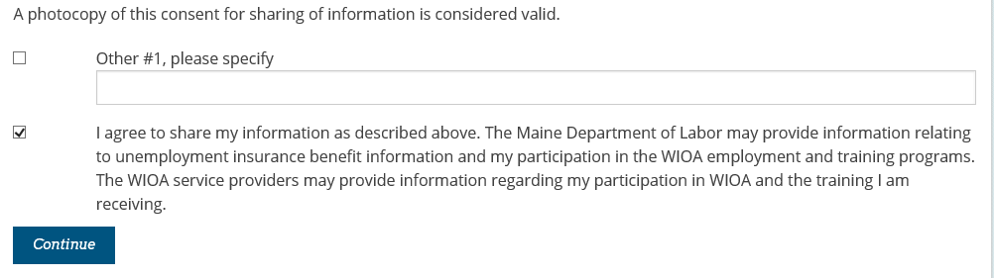

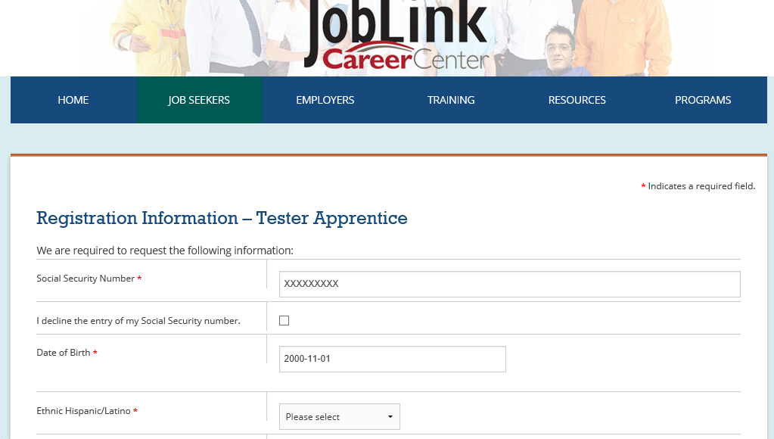

At the **Registration Information** screen, your Social Security Number will appear as XXXXXXXXX. Do **not** change the X’s.

* Date of Birth appears – confirm accuracy – no need to retype if accurate
* Use dropdowns or check boxes to answer all the additional registration questions

1. Click in each box with your cursor tocomplete the sections**.** The red asterisk indicates a required field.
2. Select ‘Yes’ when asked if you are a registered apprentice. The Registered Apprentice (RA) Number box appears. Use your 12-digit RA number (i.e., ME2019000576). If you do not know your RA number, call the Maine Department of Labor’s Bureau of Employment Services at (207) 623-7981 for assistance.

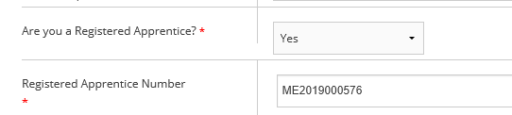

1. Continue to answer the questions for each screen. At the bottom of each screen click on Next in the blue box**.** If you click on ‘yes’ you may be asked to provide additional information. All information asked will be kept confidential and used to help the Apprenticeship staff to better provide you with assistance.



**Here are the categories:**

* **Veteran and Veteran Spouse Information –** if you have served on active duty with the armed forces of the United Stated or are the spouse of an active duty service member or veteran, click on the down arrow in the box and select ‘yes’. This will prompt additional questions for you to answer.
* **Migrant or Seasonal Farmworker Status –** because you are employed, click on the down arrow in the box and select, ‘No.’
* **Employment Status screen –** because you are employed, click on the down arrow and select ‘employed’. You will also have to answer if you “Are employed at less than full time, or at jobs inadequate with respect to your training or economic needs?” Click on the down arrow and select ‘no.’
* **Unemployment Insurance Status –** because you are employed, you will click on the down arrow and select ‘not receiving UI benefits.’
* **Selected Service Status –** click on the down arrow and select your answer. If you are female, you may select ‘exempt from Selective Service.’ If you are male and you select ‘no,’ a link will pop up that will take you to where you may register online with the Selective Service.
* **Eligibility to Work in the U.S. –** click on the down arrow and select, ‘U.S. citizen’**.**
* **Dislocated Worker Status –** click on ‘none of the above.’

The **Edit Work Wanted** screen should appear.

1. Click in the box to type your job title (Your Apprenticeship Occupation)



1. Click Update Work Wanted
2. At the next screen, **Select Occupation – Work Wanted**,matches will appear – click on the job title that best fits the occupation you are currently an apprentice in - the system will automatically advance to the next screen

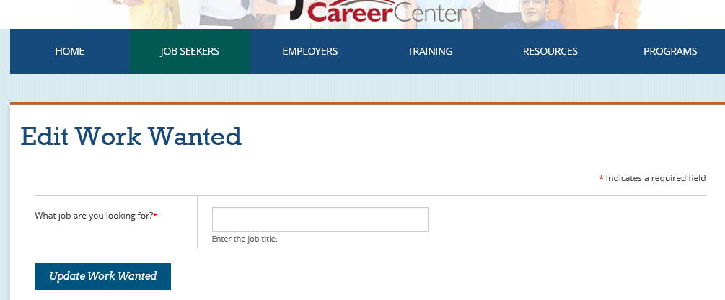

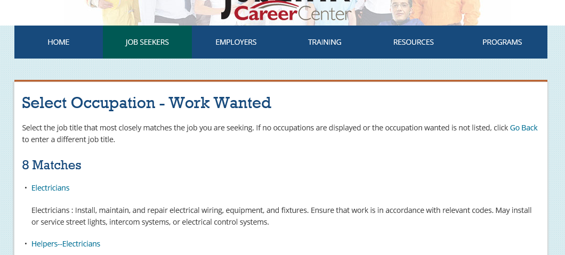

A snapshot of your **Demographic Information** appears

1. Review all information for accuracy. *If changes are necessary, click on any “blue” Major category to make necessary edits.*

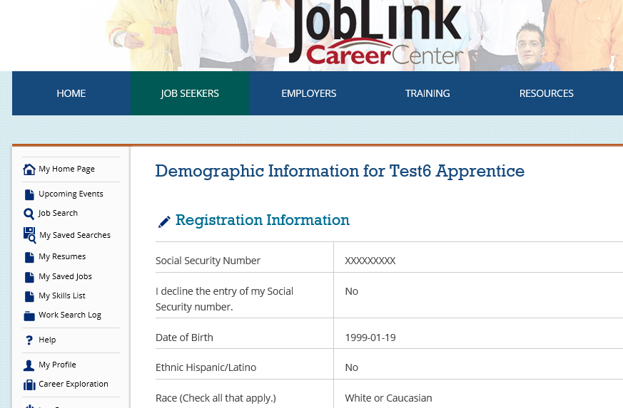

1. Scroll down to bottom of page and click on **Continue.**



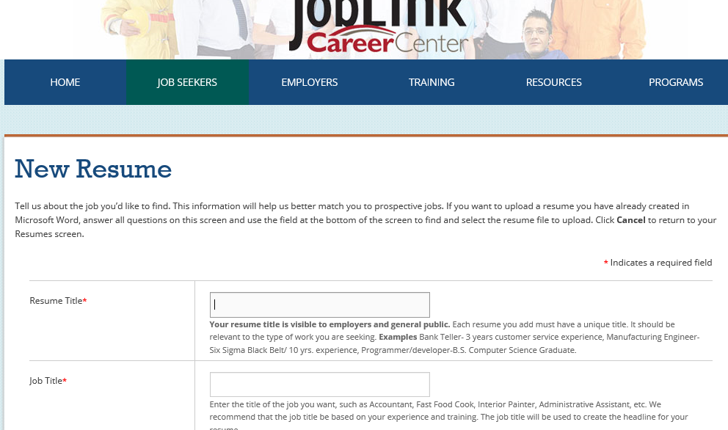

The **NEW RESUME** screen appears. **Note:** Because you are already employed, this is how you navigate through the resume portion of the registration process.

To confirm your apprenticeship participation, this screen must be completed even though you are already employed.

1. Click in the box with your cursor tocomplete the sections**.** The red asterisk indicates a required field.For the resume title you may use *(your occupation)*
2. For the Job Title: Type the word “apprentice”
3. Continue to fill in/answer sections on this page.

**Special Note: If you are already working in an occupation as an apprentice, it is optional to add/create a resume. If you do not want to add/create a resume follow these steps:**

1. At the bottom of the page, choose Create Resume (Yes, you will choose Create Resume and leave most of the screen sections blank.)

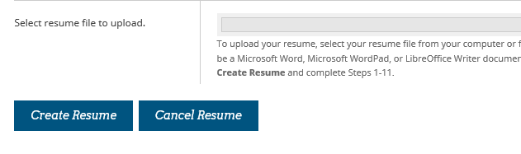

**Navigate through the following screens:**

* Select Occupation – Work Wanted for Apprentice: select the best match
* Objective Statement for (Occupation)**:** bypass the information and scroll to the bottom of the page and select ***Update Resume***
* Summary of Qualifications for (Occupation): bypass the information, scroll to the bottom of the page and select ***Update Resume***
* Address Book: review the information and select ***I Have No More to Add***
* Work Experience: select ***I Have No More to Add***
* Education: select ***I Have No More to Add***
* Review/Edit Selections: by pass the information, scroll to the bottom of the page and select ***Save and Continue***
* Resume Review: select ***Proceed Anyway*** the next screen will show you the generated information.
* Scroll to the bottom and select ***Finish***

On the next screen you should have notification that your Resume was successful activated.

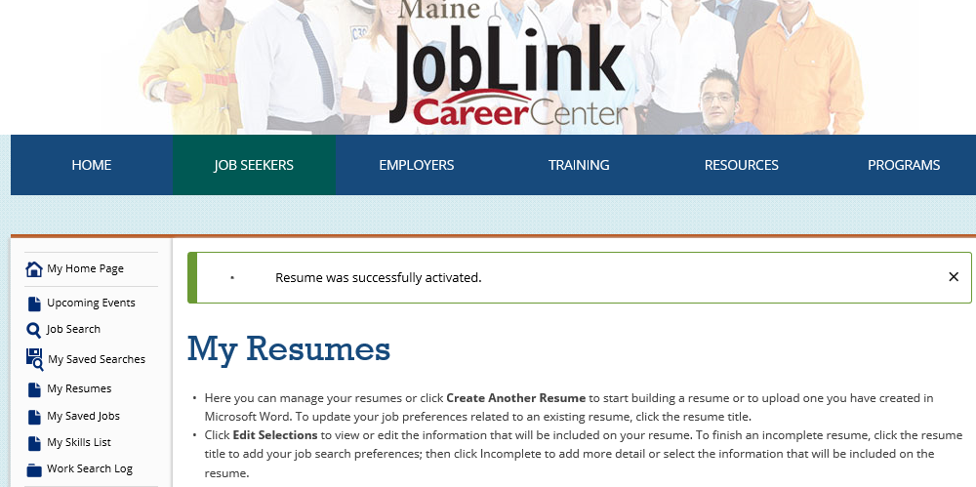

**Confirming Your Completed Account Registration**

1. From the Home Page click on ‘**My Profile’** located in the left side column.
2. Scroll down and click on the section **‘Personal Information’**.
3. Then click on **‘Edit Personal Information’** to open the section – check to make sure all information is complete – make necessary edits.
4. Scroll to the bottom of the screen and click on **‘Continue’** in the blue box.
5. The next screen will show the confirmation of completion with the customer’s first and last name.
6. To print, press and hold the “Ctrl” key and press “P” on the keyboard.

